Name: Aditya Matale

Class: AIDS-B

Roll No: 25

-----------------------------------------------------------------------------------------------------------------------

SHELL SCRIPTING

Q] What is meant by Shell?

A] In computing, a shell refers to a user interface that provides access to an operating system's   
 services and resources. It is a command-line interface (CLI) or graphical user interface (GUI) that   
 allows users to interact with the computer's operating system.

Q] What is mean by the Shell Scripting?

A] Shell scripting involves writing scripts (sequences of commands) in a shell language (such as Bash   
 scripting) to automate tasks, perform system administration, or execute a series of commands.   
 Shell scripts can be used to simplify complex tasks and workflows.

Q] Features of Shell scripting?

A] Shell scripting provides a means to automate tasks through commands, variables, and control   
 structures. It enables file manipulation, text processing, and system interaction, offering a versatile   
 tool for streamlining workflows and managing operations. Additionally, it supports customization,   
 making it adaptable to specific needs.

Q] Difference between the scripting and programming?

A] Scripting typically involves writing interpreted code that automates specific tasks or coordinates  
 existing software components. It focuses on simplifying repetitive operations. Programming, on   
 the other hand, involves creating compiled or interpreted code for building complex applications,   
 emphasizing design, algorithms, and software architecture.

1] Calculate the Simple Interest (assuming own input) and check whether it is greater than 10000 or not (use if statement).

EDITOR:

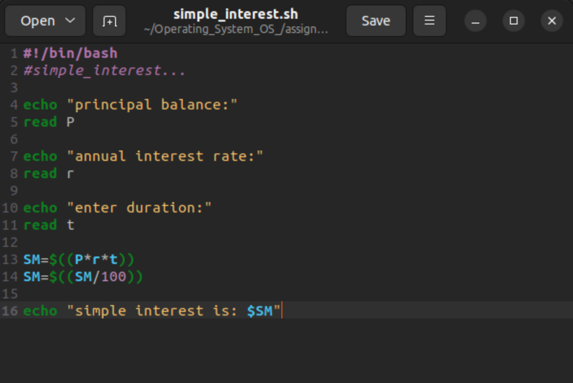

TERMINAL:

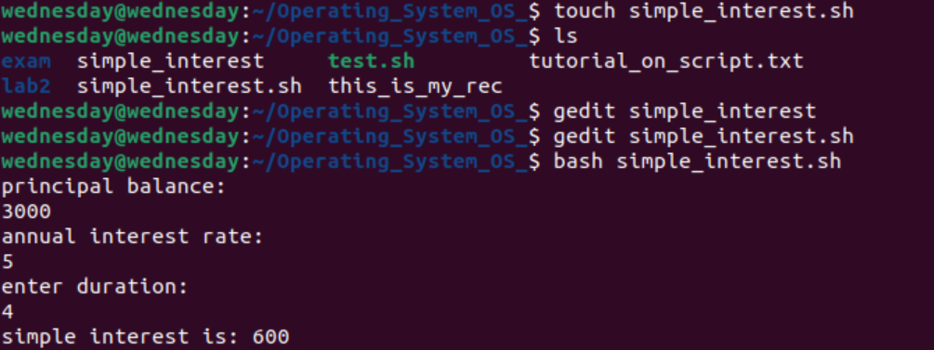

2) Display the sum of first 50 numbers using the for loop.

EDITOR:

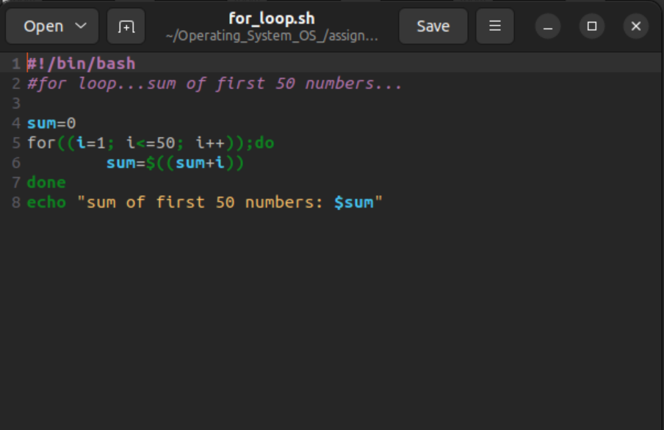

TERMINAL:

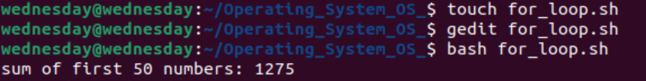

3) Accept and display the data through command line Arguments.

EDITOR:

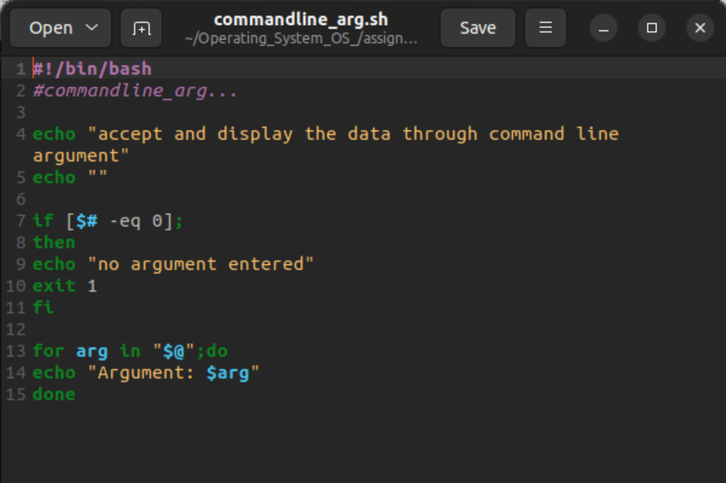

TERMINAL:

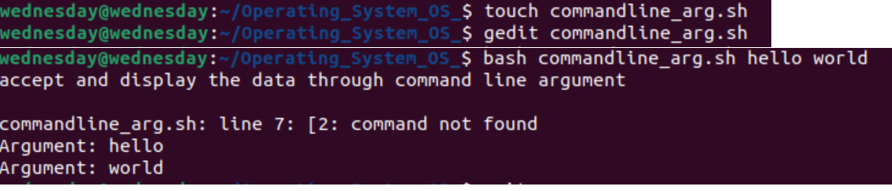

4) Sort the array element in descending Order.

EDITOR:

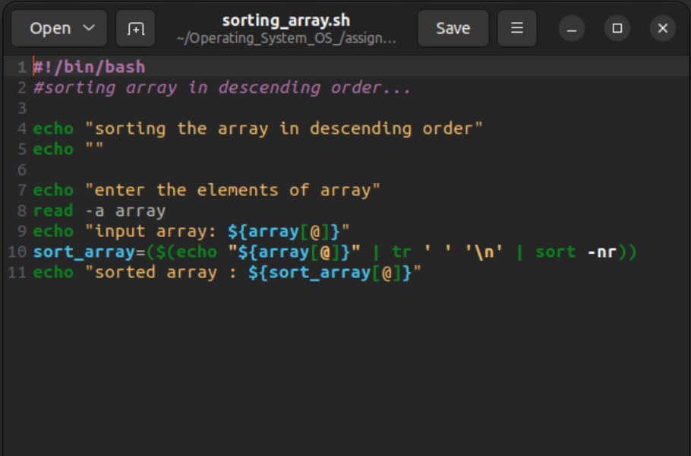

TERMINAL:

